EXPERIMENT- 11
Perform Affine Transformation on the Image
Aim
To write a Python code to perform affine transformation on an image using OpenCV for rotating and transforming the image while preserving parallel lines.
Input Image
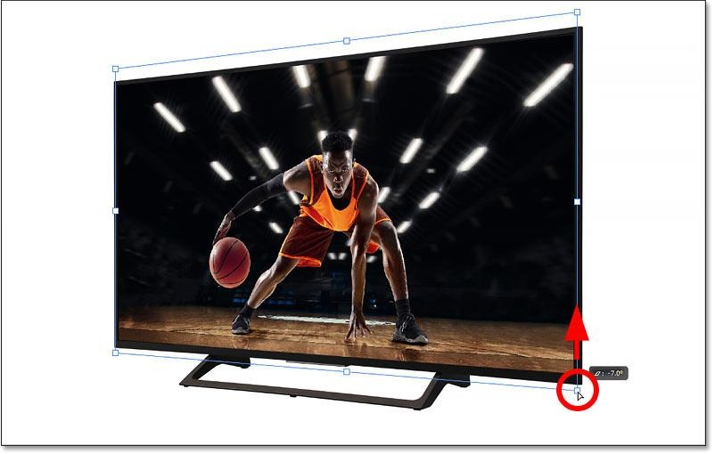
Code
import cv2
from google.colab.patches import cv2_imshow
from google.colab import files
uploaded=files.upload()
image_path=list(uploaded.keys())[0]
image=cv2.imread(image_path)
if image is None:
print("Error: Image not found")
else:
angle=45
scale=1.0
rotation_matrix=cv2.getRotationMatrix2D((image.shape[1]/2,image.shape[0]/2),angle,scale)
output_image=cv2.warpAffine(image,rotation_matrix,(image.shape[1],image.shape[0]))
print("Original Image")
cv2_imshow(image)
print("Affine Transformed Image")
cv2_imshow(output_image)
Output Image
Affine Transformed Image
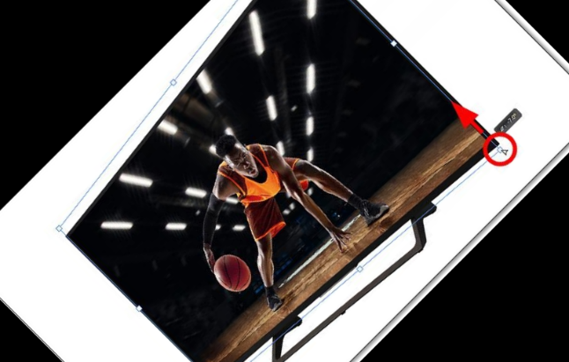
Result
Thus, affine transformation was successfully performed on the image using OpenCV.

